**Overworld**

**General Overview** 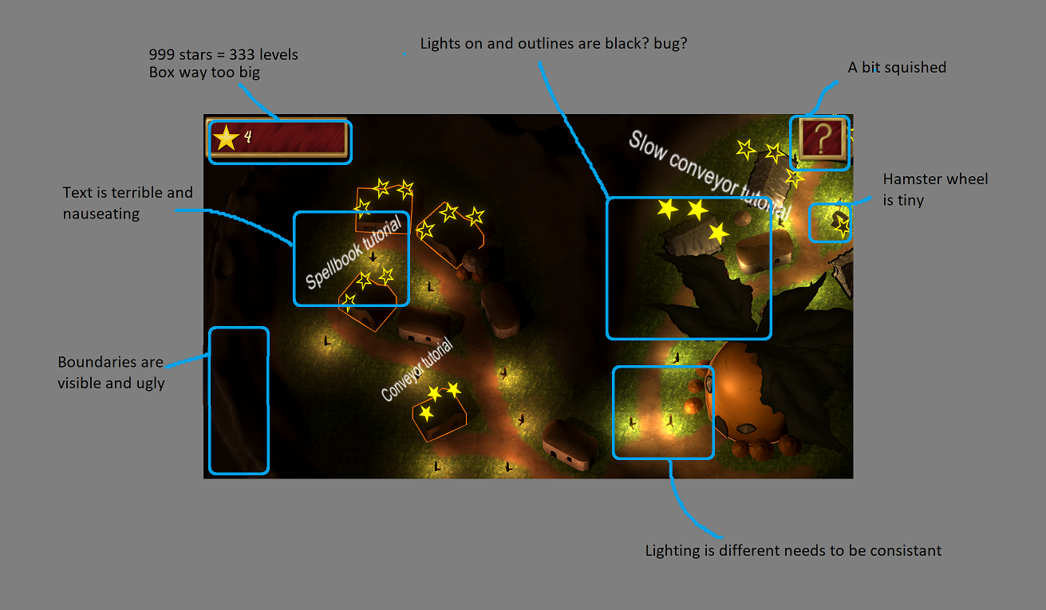

**Levels**

**Tutorial**

**Conveyor Tutorial**

**Entry Screen**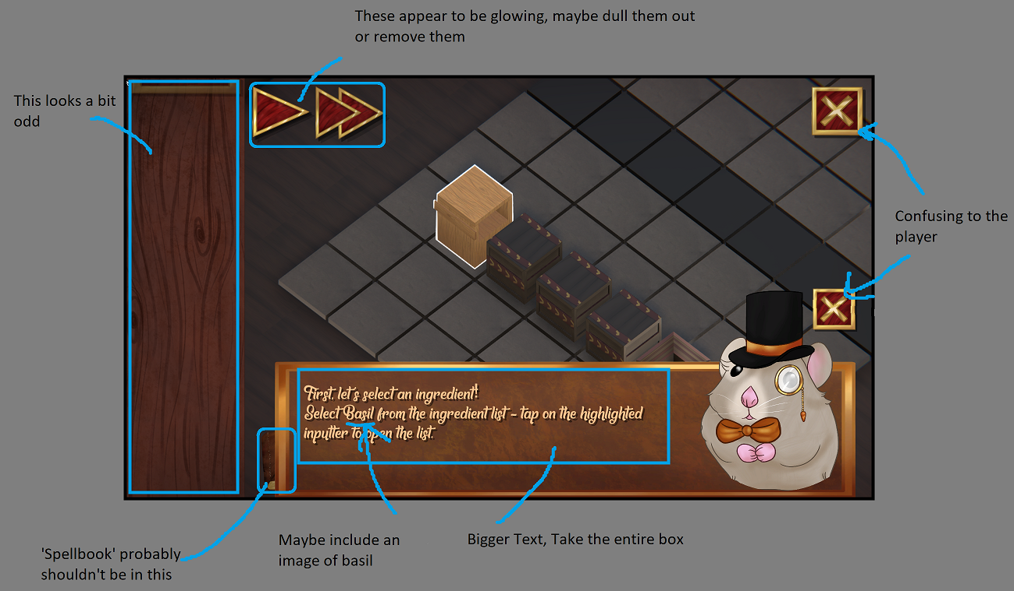

**Progression (Ingredient select)**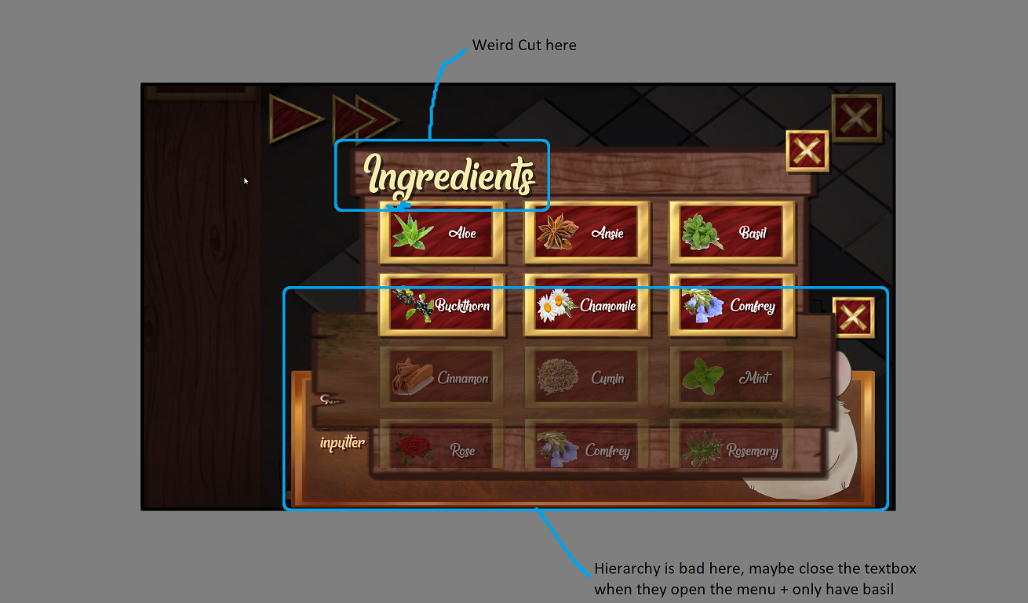

**Progression (Play Button)**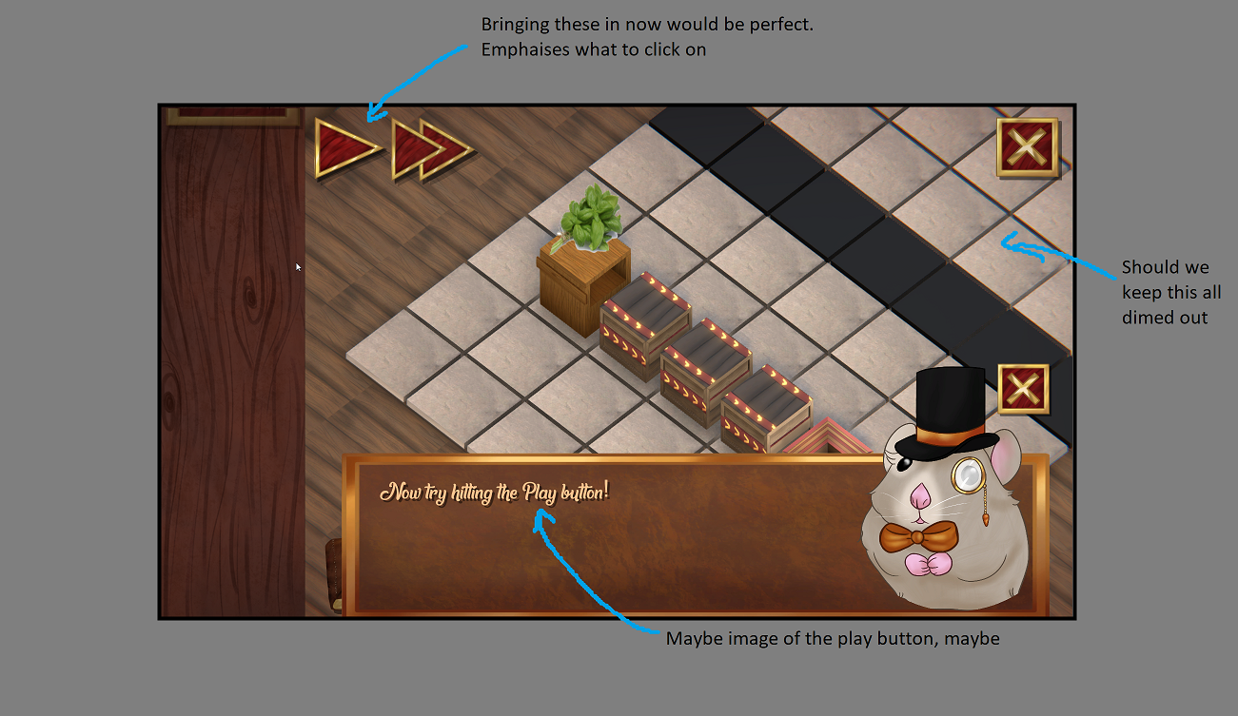

**Progression (Do-it-yourself)**

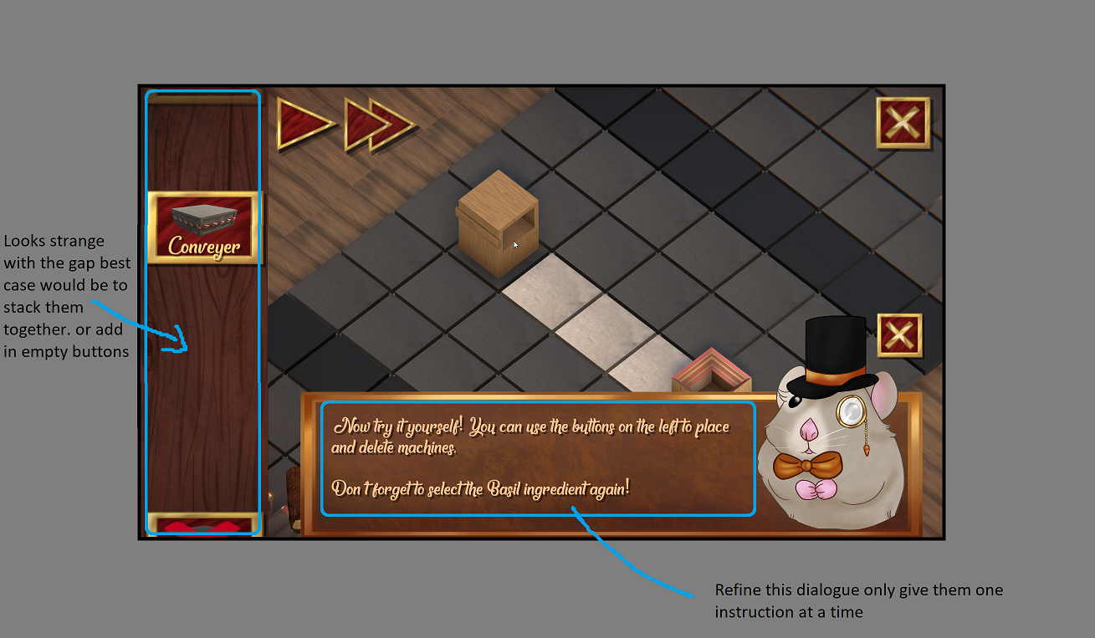

**Progression (Rotation Tutorial)**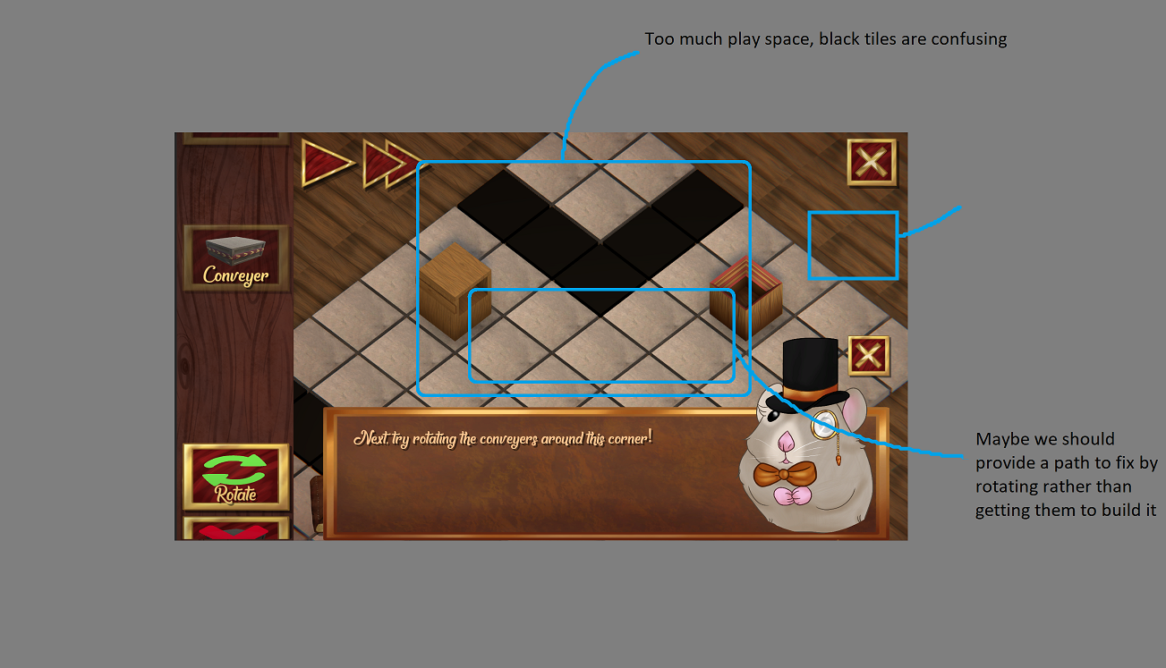

**Progression (Tutorial End)  
